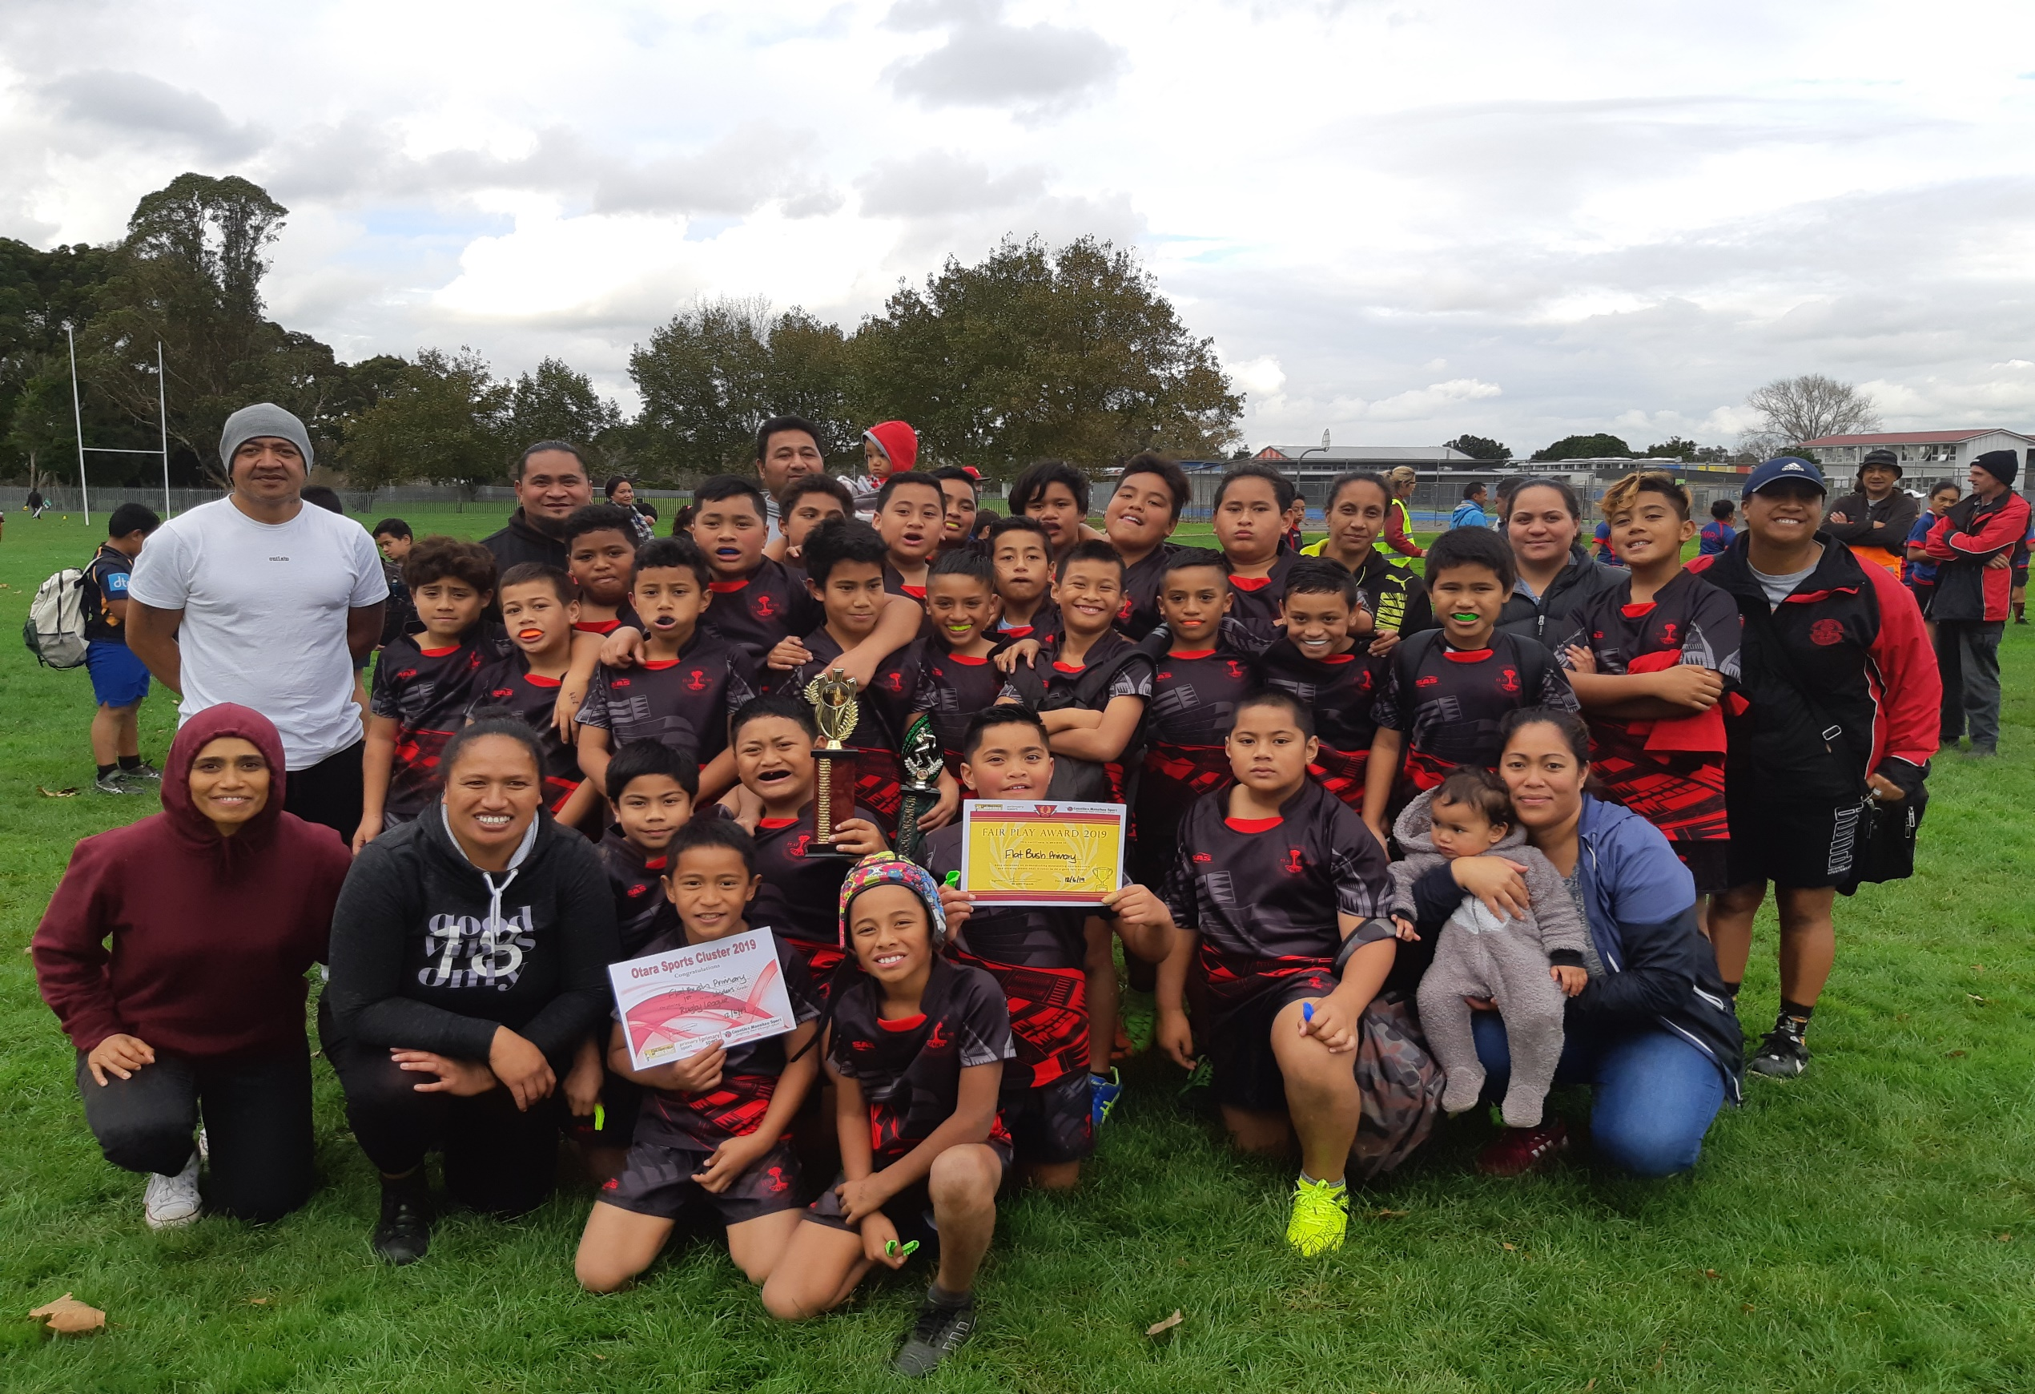
2020 Annual Plan
Strategic Plan
2020-2022
Charter 2020
Vision:
“Success for all”
kia angitu tātou katoa
“To provide children with opportunities to be confident, connected and actively involved lifelong learners who are proactive citizens of the world”.

SCHOOL MOTTO:
“Strive while young”
Mahia nga mahi nei tamariki ana
The Flat Bush Learner

Learner questions, shows initiative and strives to succeed .
Effective at working co-operatively and independently.
Able to read, write and speak with confidence.
Realises the importance of being honest and fair.
Nurtures and respects the environment,
themselves and others.
Enthusiastically participates in school and community activities.
Reliable and responsible.
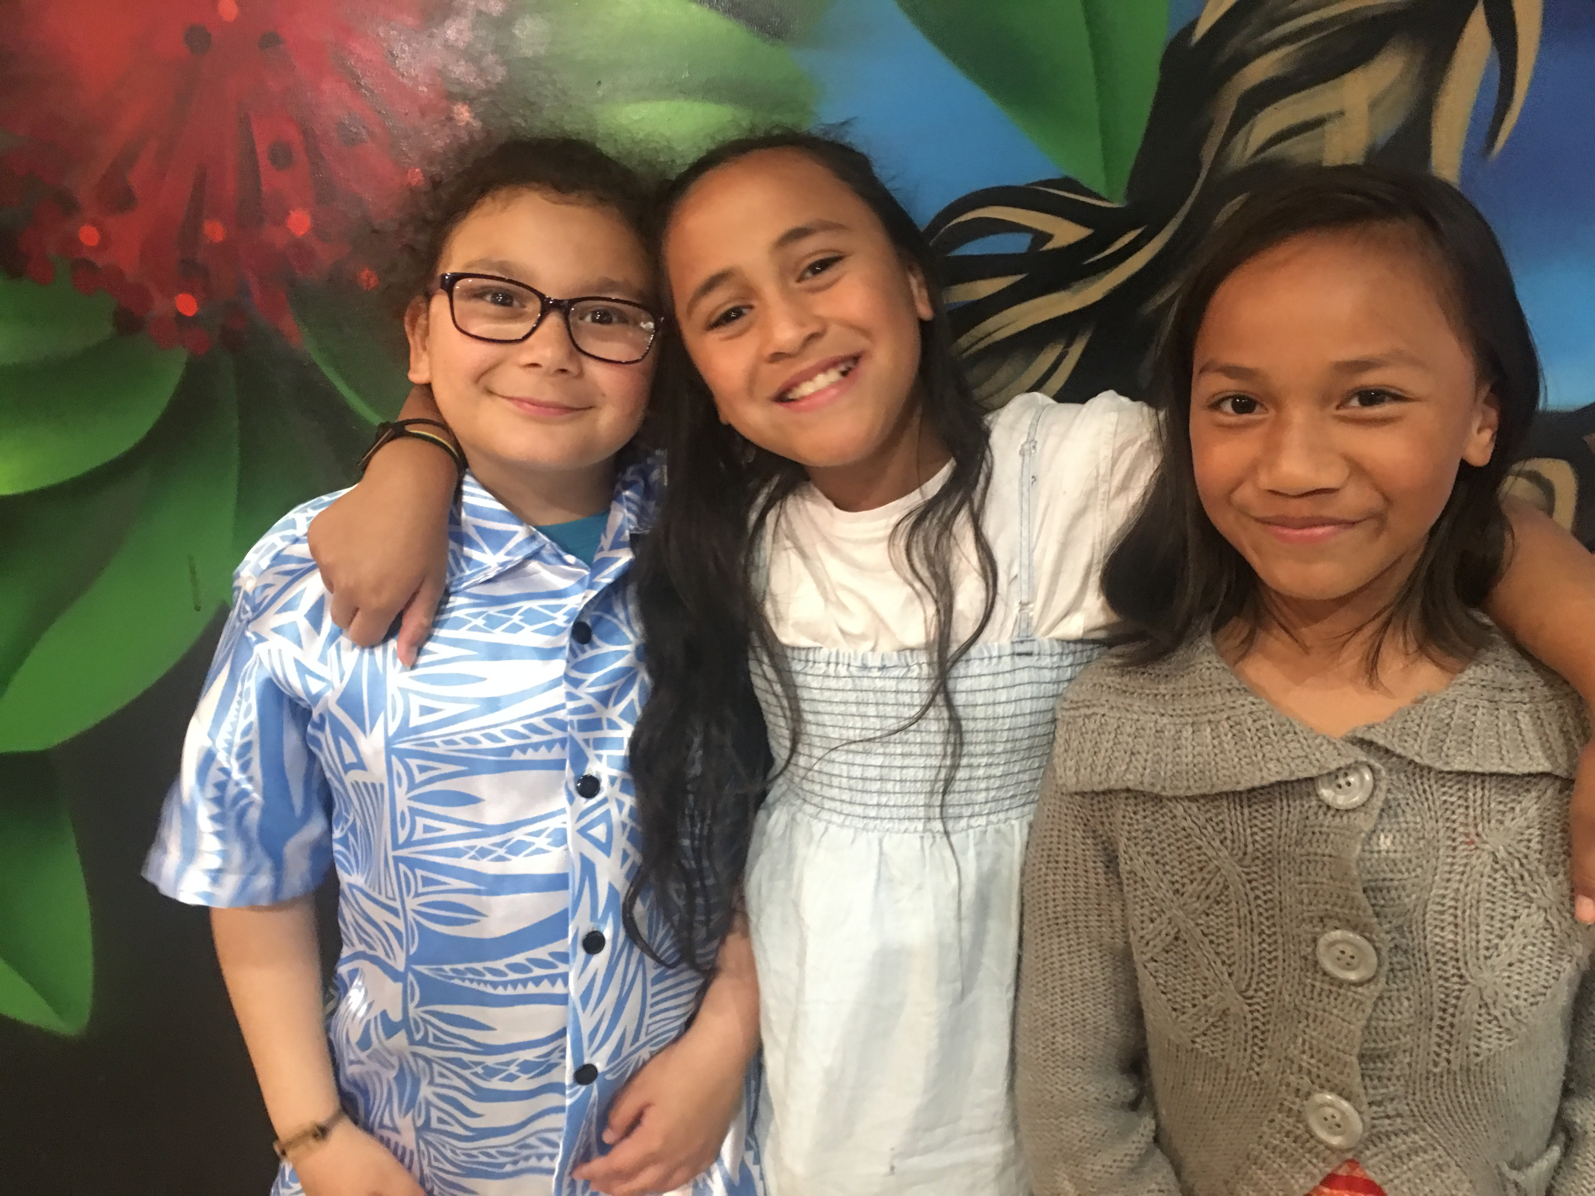

Flat Bush Values

Whakawhanaungatanga: In the sense of whanau and school working together to reflect our community’s values;
‘we work for each other’

Manaakitanga: Caring for and respecting each other;
‘we care about others’

Atawhai: Whanau and school working together to nurture the students
‘we value others’

Tu pono: Knowing oneself, one’s identity;
‘we know who we are’

Mahi Ngatahi: Working collaboratively;
‘we work as a team ‘

Arohatia: Nurturing showing approval;
‘ we encourage others’

Flat Bush Values

Gagana ma Anganu’u: Treasure your language, culture and identity

Alofa: encompasses love, sharing, charity, sacrifice and commitment

Fa’aaloalo: reciprocal respect and involves honouring others, especially elders or those of senior status

Fealofani: Working together

Tautua: Is serving others in the aiga (family) lotu (church) Nu’u (village) and paepaega o tagata (community)

FLAT BUSH MISSION STATEMENT

1. Children will demonstrate a high level of self-worth and resilience. (Self-worth and resilience are enhanced by areas such as wairua, spirituality, culture, the arts, academic success and sport. Children are treated holistically)

2. Children will be confident, competent, inquiring, self-motivated lifelong learners. (Striving to reach their best)

3. Children will be effective communicators who can work cooperatively and collaboratively. (In English and their home language)

4. Children will be responsible and active global citizens.

By the time children leave school at year 6, students will be actively involved lifelong learners.
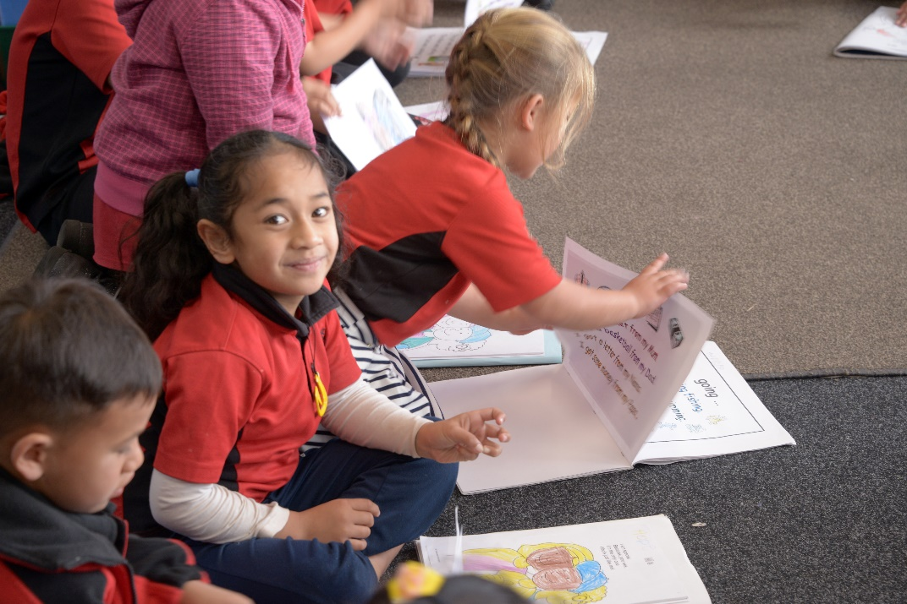

WHO WE ARE…

Flat Bush is a decile 1 school in Otara, Manukau City, opened in 1964. The school has a roll of between 440-460 students.
We serve a predominantly Pasifika Maori community, with a significant number of children from non-English speaking backgrounds and a number of our children start school with a limited knowledge of and consequent language difficulties. There is an increasing amount of participation in Early Childhood Education in the community. We have engaged the support of our local Early Childhood Centres within our Kāhui Ako as a means of improving in this area. Our children come from a variety of Pacific backgrounds and Iwi. As is the case in other parts of Auckland there are a high number of rental properties in the area, and a high level of pupil transience. Our school includes a satellite unit from Mt Richmond Special School consisting of two classrooms which were completely refurbished in 2017. We have close links to our local kindergarten which borders our school grounds. In 2020 our specialist classes include three Samoan Focus classes, a Maori focus class ,the Garden to Table Programme, specialist Te Reo Māori and Physical Education lessons for all year levels as well as a strong sporting programme. Aligned with that will also be our STEAM classes that will be delivered across all year levels. In 2020 we will be operating within 3 learning teams and each team consists of a minimum of six classrooms. We are part of the Te Puke ō Taramainuku Kāhui Ako.
Cultural Diversity and Tikanga Maori
Flat Bush School recognises the importance of all aspects of both Maori and the various Pasifika cultures that make up our student population.
The school currently has three Samoan Focus classes in Yrs 1-2, 3-4 and 5-6 as well as a Maori Focus class for students in Years 4-6.
We value children’s ethnic heritage and home language and work to maintain this. Encouraging parents in the use of children’s home language and its importance is a key part of our message to parents. Instruction in Tikanga Māori and Te Reo Māori will be provided in all classes by the class teachers and professional development will be available when needed by teachers. The teaching of Te Reo will be at a basic level. School activities will be designed, where possible to include and acknowledge Tikanga Māori. Parents who wish to have their children taught Te Reo at a higher level (ie immersion or bi-lingual) will be advised to try and enrol them in another school which is able to provide such instruction. Should a sufficient number of parents request bi-lingual or immersion teaching of Te Reo the board would consider how this might be provided. Our Board of Trustees believes there is a place at Flat Bush for a Māori Focus class and that through exploration of Te Aō Māori these students will continue to develop and build a greater understanding of their culture and identity. We continue to support the Te Reo of children coming in from Kohanga or Kura Kaupapa while at the same time ensuring their success in English. The needs of Māori children entering the school need to be constantly assessed and catered for.

Learning Assistance
Special needs students are always welcome at Flat Bush. We have a fully released SENCO whose role is to ensure maximum support is always available to both the students and their families as well as the staff involved. Special Needs students, other than those in the Mt Richmond class are always integrated into the mainstream and most interventions occur in the context of the child’s normal class programme. Mt Richmond children are integrated when and where appropriate. Whanau are always welcome, and are an integral part of planning processes through IEPs as well as more general discussions that occur with them on a regular basis.

Te Puke ō Taramainuku Kāhui Ako

Te Puke ō Taramainuku Kāhui Ako Strategic Plan 2020-2021
MISSION  “to continue to have an inclusive community that evokes and enables lifelong learning” | VISION  “ko te akoranga e koe e mimiti”  Learning without limits | VALUES  Nurturing/Inclusive/Connected/Empowering  N.I.C.E.
GOALS | INITIATIVES | SUCCESS MEASURES
WRITING  Within our overall goal of shifting 232 additional students there are 3 sub-goals that are a collective focus:Māori/Pasifika/Boys | - Terms 1-3 Kāhui Ako curriculum evenings  - T2 PLD Day with E-AsTTle workshops (Years 1-10)  - Sharing expertise across Kāhui Ako  - Kāhui Ako Writing showcase as part of Term 3 Student Expo  - Promote a Growth Mindset mentality for teachers and learners  - ASLs/WSLs leading development of our Te Puke ō Taramainuku Local Curriculum  - Pacific Parent Responsive Education Programme will be delivered across our Kāhui Ako (February-October) | Years 1-8  - Māori: We aim to lift the achievement of all our Māori students in Writing from 50.1% (133/265) to 80% (212/265), a 29.9% shift by the end of 2021.  - Pasifika students: We aim to lift the achievement of Pasifika students in Writing from 60.4% (467 /773 ) to 80% (618/773), a 19.6 % shift by the end of 2021.  - Boys: We aim to lift the achievement of boys in Writing from 51.3% (279/543) to 80% (434/543), a 28.7% shift by the end of 2021. This is a shift of 155 more boys  Year 10  - We aim to lift the achievement of Year 10 students to 85% at or above expected achievement level, a 7% shift by the end of 2021.
MATHEMATICS  Within our overall goal of shifting 234 additional students there are 3 sub goals that are a collective focus: Māori/Pasifika/Boys | - Terms 1-3 Kāhui Ako curriculum evenings  - T2 PLD day with a focus on DMIC  - Sharing expertise across Kāhui Ako  - Promote a Growth Mindset mentality for teachers and learners  - ASLs/WSLs leading development of our Te Puke ō Taramainuku Local Curriculum  - Pacific Parent Responsive Education Programme will be delivered across our Kāhui Ako (February-October) | Years 1-8:  - Māori: We aim to lift the achievement of all our Māori students in Mathematics from 49.8% ( 132 /265) to 80% (212/265), a 30.2% shift by the end of 2021.  - Pasifika students: We aim to lift the achievement of Pasifika students in Mathematics from 59.7% (455/762) to 80% (610/762), a 20.3% shift by the end of 2021.  - Boys: We aim to lift the achievement of boys in Mathematics from 51.8% (277 /534) to 80% (427 /534), a 28.2 % shift by the end of 2021.
NCEA LEVEL 2 and 3 | - Pacific Parent Responsive Education Programme will be delivered across our Kāhui Ako (February-October)  - Sharing expertise across Kāhui Ako  - Promote a Growth Mindset mentality for teachers and learners | - Level 2: we will achieve 91.5% (143/156), a 7.5% shift by the end of 2021. This will mean shifting 12 additional students from Not Achieved to Achieved.  - Level 3: we will achieve 91% (110/121), a 7.5 % shift by the end of 2021. This will mean shifting 9 additional students from Not Achieved to Achieved.  - We will achieve a 2.5 % shift annually.
PROCESS TARGETS  - Learner Well Being  - STEAM  - Learner retention, attendance and engagement | - By the end of 2020 Kāhui Ako leaders and teachers will have identified an appropriate methodology to collect data on well-being.  - This will include using the Well Being at School tool https://www.wellbeingatschool.org.nz/ws-surveystools  - We will explore current practices around effective Well Being practices. | - 80% of whānau complete and return NZCER Student Well-Being survey  - 100% of our Te Puke ō Taramainuku learners state that they feel safe, happy and secure at school  - Promote student agency by highlighting the partnership between teacher and learner  - Strengthen connection between our students and others in our Kāhui Ako
 | - Develop a local curriculum that reflects STEAM concepts and competencies, community partnership and authentic learning.  - Term 3, 2020 Kāhui Ako STEAM themed Student Expo  - Develop assessment literacy practices related to key competencies & learning dispositions | - By the end of T3, 2020 we will have a Kāhui Ako Student Inquiry model  - 80% of all whānau will attend our Term 3 Kāhui Ako STEAM Student Expo  - By the end of T4, 2020 we will have a draft version of our Te Puke ō Taramainuku Local Curriculum ready for delivery in 2021
 | - Pacific Parent Responsive Education Programme will be delivered across our Kāhui Ako (February-October)  - Monthly Te Puke ō Taramainuku Attendance meetings with STRIVE  - Maintain existing Pastoral care processes e.g. SWIS/Careers Advisor/PHN etc | - Learner attendance in all centres and schools is above 85%  - Our learners accessing educational opportunities from within our Kahui Ako from ECE- Tertiary  - Develop systems and processes to support a seamless transition across our Kāhui Ako  - Build a cohesive pathway (learning/pastoral) that works alongside the local curriculum design.

Mathematics
Mathematics: to increase the number of children achieving at or above expected progress in Mathematics

Mathematics achievement levels 2017-2019

MATHEMATICS | 2017 | 2018 | 2019
Above standard | 18.6% | 14.5% | 17.3
At Standard | 42% | 35.8% | 48.2%
Below Standard | 30.3% | 38.1% | 30.3%
Well Below Standard | 10.5% | 6.0% | 4.2%

From 2018 all year levels implemented the Developing Mathematical Inquiry Communities (DMIC) approach to the delivery of Mathematics.

2020 Goal: Our goal therefore for 2020 is to have 80% of all students at or above their expected level of achievement in Mathematics, this is an increase of 14.0% from our 2019 end of year data.

Target 1: To raise student achievement in Mathematics

Historical Position | Strategy | Action(s) | Reflection
Flat Bush School has had PLD in DMIC with Professor Bobbie Hunter and her team | There has been evidence to support that when implemented the Pasifika Maths programme will accelerate student achievement in Mathematics. | The Pasifika Maths approach has been taught in all classes since 2018. | Positive shifts across the school as indicated by EOY data
End of year OTJ’s in 2018 showed that we have made progress in Mathematics | Continue to utilise an Inquiry approach to the teaching of Mathematics using the DMIC strategies. | All year levels will ensure that the delivery of Mathematics aligns with the FBS Mathematics Curriculum Implementation Plan | Continue with this focus and teaching approach in 2020
Flat Bush School recognises the value of continually up-skilling staff and has a commitment to high quality professional development. | Time will be given in team meetings to discuss Mathematics programmes, individuals needing enrichment or extension, research and best practice models. | The Mathematics Leader will ensure, through regular meetings and through the professional development plan, that staff have access to the latest research and best practice. | Several teachers in 2018 attended PLD courses during term breaks. Teachers will be encouraged to focus TAI in Mathematics.
In 2017 the Flat Bush School Mathematics Curriculum Implementation plan was written. | Our FBS MCI outlines how Mathematics will be delivered across our school at all year levels | All year levels will ensure that the delivery of Mathematics aligns with the FBS Mathematics Curriculum Implementation Plan | Continue with this focus and teaching approach in 2020
We are very involved with learning experiences outside the classroom, including inquiry throughout the process. | Share in learning experiences through the inquiry process that focus on involved with the learning experiences. | Set up ‘Rich, Real and Relevant Experiences” to enrich the Mathematics experience. Set up programmes that motivate and inspire students to want to do Mathematics. | Continue with this focus and teaching approach in 2020
All classes in Yrs 1-2 have access to 8 Ipads and all classes in Yrs 3-6 have 25 chromebooks | Students in all classes will have access to an ICT device for Mathematics. | Students in all classes will have access to appropriate on-line Mathematical learning tools | Continue with this focus and teaching approach in 2020

Target 1a: To raise student achievement in Mathematics

Student achievement target action plan
Annual Target  To accelerate the Mathematical achievement of students identified as a cause for concern in Mathematics.  All Year 6 male Pasifika students well below expected achievement level to make accelerated progress that will enable them to finish the year at expected level. |  |  | Student Group  Gender: Male and Female  Ethnicity: Maori and Pasifika  Student Year: 6  Targeted group: All Year 6 Maori and Pasifika students below expected progress level in Mathematics
Historical Position
Teachers have had PLD in the teaching of Mathematics through an Inquiry based approach (DMIC)
Action Plan
What will the school do to meet the target | When will it be done by | Who is involved / responsible |  | What resources will be allocated
Leader for Mathematics will be selected from current staff.  The Mathematics Action Plan to be reviewed by Mathematics Team Leader and SMT.  On-going development of benchmarks for student achievement in line with Mathematic progressions and the New Zealand Curriculum.  Obtain data on student achievement via diagnostic testing E-AsTTle/GLOSS/JAM.  Time 1 goals to be created with students to prepare for Goal setting evening.  Regular conferencing with students and using data to inform and co-construct learning intentions and success criteria with students.  Mid year data will be collected and analyse and placed onto Etap  Children are given daily opportunities to do Mathematics with clear learning focus, feedback and next step.  Including Learning experiences outside the class, all aligned with our FBS Mathematics Curriculum Implementation Plan  Target group students will be discussed at Team meetings and strategies to accelerate their learning will be shared  Analyse student data across strands and cohorts at the end of the year and identify areas for improvement in the following year.  Prioritise spending and resourcing and allocate sufficient funds for 2020  Work alongside colleagues in our Kāhui Ako in sharing examples of best practise, planning and learning programmes | Week 5, Term 1  End of Term 1, 2020  Week 8, Term 1,2019  Ongoing from Wk 3, T1  Week 9, T1  Ongoing | SMT  Maths Co-leaders and team  Maths team/all teachers  Teachers  Teachers  Teachers |  | Fixed Term Unit for leader  Time ($300)  Release for Math team leader  After school curriculum team meeting  Assessment tool kits  Week 8, T1 staff meeting  Syndicate meetings
 | Terms 1-4  Terms 1-4  Week 4, T1 onwards  By the end of Week 6, T4 2020  Term 1 onwards | Teachers  Students  Teachers  Students  Teachers  Teachers  Teachers/Maths team leader  /syndicates/SMT |  | On-going  Cost of external learning experiences  Trip costs  Week 4 Staff Meeting  Team meetings  Time  Possible release time
Success Criteria:
End of Year assessment data
All students to make accelerated progress from start of the year

Written Language: To increase the number of children achieving at or above expected progress in Written Language
Current Situation: Written Language achievement based on 2017-2019 results

WRITTEN LANGUAGE | 2017 | 2018 | 2019
Above Standard | 11.8% | 14.0% | 16.2%
At Standard | 34.7% | 43.4% | 49.1%
Below Standard | 41.7% | 35.4% | 28.1%
Well Below Standard | 11.8% | 7.2% | 6.6%

These results indicate a positive shift in students At or Above expected progress levels. Increased analysis and understanding of assessment data has ensured greater validity in OTJ’s. Teachers in our Senior Syndicate focused on Writing in their Teacher Inquiries.

TARGET
For 2019 our target group is anyone achieving below expected progress and in particular those just below standard, with the goal of reaching 80% at or above by the end of the year. Oral language continues to be the driver for improving written language.

Success Criteria
To have 80% At or Above expected progress in Written Language.

Target 1: To raise student achievement in Writing
Historical Position | Strategy | Action(s) | Reflection
End of year data in 2019 showed that we have made positive progress in Writing | 2020 PLD will continue to focus on Assessment for Learning (Afl) | Literacy Leader and team will write the Action Plan and present this to the board. The Literacy leaders will review all the documentation on pupils and look at the needs.
Flat Bush School recognises the value of continually up-skilling staff and has a commitment to high quality professional development. | Time will be given in staff and curriculum meetings to discuss Literacy programmes, individuals needing enrichment or extension, research and best practice models. | The literacy leaders will ensure, through regular meetings and through the professional development plan, that staff have access to the latest research and best practice.  Staff will complete a teacher led inquiry as part of their 2018 Appraisal. This may have a focus on Writing.
We had teachers engaged with the ALL programme in 2016/17 | We will continue to share and integrate learning from our time in ALL in order to accelerate their progress. | Literacy Leader and Lead teachers will continue to share with teams examples of Best Practice
School has developed a CAAP plan as part of Years 1-2 of ALL. | Syndicates with the support of Lead Teachers in Literacy will review current CAAP and make alterations when and where necessary | Review current CAAP plan and make relevant additions or alterations (on-going)
We are very involved with learning experiences outside the classroom, including inquiry throughout the process. | Share in learning experiences through the inquiry process for report and recounts involved with the learning experiences. | Set up ‘Rich, Real and Relevant Experiences” to enrich the writing experience. Set up programmes that motivate and inspire students to write.
All classes in Yrs 1-2 have access to 8 Ipads and all classes in Yrs 3-6 have 25 chromebooks | All students will have access to an ICT device relevant to the learning experience | E-Learning Lead Teacher to support teachers to source and locate learning experiences that will motivate our students e.g. www.literacyshed.com

Target 1a: To raise student achievement in Writing
Student achievement target action plan
Annual Target  80% of all students at or above expected progress levels in Writing |  |  |  | Student Group  Gender: Male and Female  Ethnicity: Maori and Pasifika  Student Year: 6  Targeted group: Year 6 Maori and Pasifika students Well Below expected progress level in Writing
Historical Position
Teachers have had PLD in the teaching of writing throughout 2014/15 with Stephen Graham and also Vision Education with Accelerated Learning in Literacy (ALL) 2016/17

Action Plan
What will the school do to meet the target | When will it be done by | Who is involved / responsible | What resources will be allocated
Curriculum leader for Reading and Writing to be selected from current staff.  The Writing Action Plan to be reviewed, written and followed.  On-going development of benchmarks for student achievement in line with Literacy progressions and the New Zealand Curriculum.  Obtain data on student achievement via diagnostic testing E-AsTTle. Analyse written work samples according to E-AsTTle matrix.  Time 1 goals to be created with students to prepare for Goal setting evening.  Data entered onto Etap.  Each class will design and implement a programme catering specifically to the needs of their students based on the data.  Regular conferencing with students and using data to inform and co-construct learning intentions and success criteria with students.  Mid year data will be collected and analyse and placed onto Etap  Model correct writing (shared book, E-AsTTle and National Exemplars, LLP).  Children are given daily opportunities to write with clear learning focus, feedback and next step. Including Learning experiences outside the class.  Analyse student data across strands and cohorts at the end of the year and identify areas for improvement in the following year.  Prioritise spending and resourcing and allocate sufficient funds for 2019.  Work alongside colleagues in our Kāhui Ako in sharing examples of best practise, planning and learning programmes | Week 5, T1 2020  End of T2,2020  Week 8, T1 2020  March 2020 | Teachers  Principal  Literacy Team  Teaching Team  Literacy Leaders  Teaching Staff  Teachers | N/A  $100.00 (folders etc)  Time ($600)  Literacy Leaders CRT  N/A
 | Ongoing  Ongoing  End of T2, 2020  Ongoing  End of Term 4, 2020  WK 4 / T4  Term 1 onwards | Teachers  Teachers  Literacy Leaders  Teachers  Teachers  Literacy Leaders Teachers  Literacy Leaders  Teaching team  Principal  Literacy Leader/syndicates/SMT | NIL  Time  Nil  Nil  Trip costs  Time  Time  Possible release time
Success Criteria
End of Year assessment data
All students to make accelerated progress from start of the year
Recommendations Differentiated groupings will be established to provide for individual learning needs. Assessment information gathered in the first half of Term 1 will be used to create these groupings. Writing will take place at least 4 times a week and all lessons are part of a school wide emphasis on Literacy

Reading:
To increase the number of children achieving at or above expected progress in Reading
Reading Language achievement based on 2017-19 results

READING | 2017 | 2018 | 2019
Above Standard | 27.1% | 27.8% | 32.8%
At Standard | 41.1% | 39.2% | 35.5%
Below Standard | 17.4% | 28.2% | 27.3%
Well Below Standard | 12.9% | 4.8% | 4.4%

End of Year OTJ’s had 68.0% of all students at or above expected progress level. Our target for 2020 is to have 80% of all students reading at or above expected progress in Reading. This is an increase of 12%.

TARGET GROUP
For 2020 our target group are our Year 6 students working well below the expected the progress level in Reading

Success Criteria
80% of pupils at or above (2018: 67.0%)
Target 2: To raise student achievement in Reading
Historical Position | Strategy | Action(s) | Reflection
We worked with Vision Education on Reading PLD in 2015/16/17 as part of ALL. | Prepare the 2019 Literacy Action Plan for the school. Ensure that we are focused on the clear links between Reading, Writing and Oral Language through the strategies being developed e.g. activating prior knowledge, visualisation etc. Review how we collect the data to inform our decisions. | Write the Action Plan and present this to the Board. The Literacy leaders will review all the documentation on pupils and look at the needs across all year levels in our school
Flat Bush School recognises the value of continually up-skilling staff and has a commitment to high quality professional development. | Time will be given in staff and team meetings to discuss Literacy programmes, individuals needing enrichment or extension, research and best practice models. Staff will be kept informed of relevant professional development offered. | The Literacy leaders will ensure, through regular meetings and through the professional development plan, that staff have access to the latest research and best practice.
We are very involved with Learning Experiences Outside The Classroom L.E.O.T.C including Inquiry throughout the process. | Share in learning experiences through the Inquiry process for report and recounts involved with the learning experiences. | Set up “Rich, Real and Relevant Experiences” to enrich reading experiences. Continue to build the relationship between our school and Te Tupu Library
Students who are achieving above the standard in reading language require further extension. | Set up an extension and enrichment programme to develop these student’s abilities. | A planned programme of enrichment and extension is available for our most able readers
Students who are achieving below the standard in reading are supported. | Reading support available to accelerate their progress student progress through Reading Recovery use of Repetitive Reading and focus on high-frequency sight words | A planned programme of improvement for children working below their chronological age.
Working Together programme well established in our school.  In 2019 this to be extended out to include the Reading Together programme | Lead Teacher to continue promoting both programmes to our school community and to provide Reading Together Workshops in Terms 2 and 4,. | Regular information made available to all families.

Target 2a: To raise student achievement in Reading
Student achievement target action plan
Annual Target  80% of all students at or above expected progress levels in Reading |  |  | Student Group  Gender: Male and Female  Ethnicity: Maori and Pasifika  Student Year: 6  Targeted group: Year 6 students achieving below expected progress level in Reading
Historical Position
There has been Supplementary Support PLD in Reading during 2015/16/17 (Vision Education) through our involvement in the Accelerated Learning in Literacy Plan.
Action Plan
What will the school do to meet the target | When will it be done by | Who is involved / responsible |  | What resources will be allocated
Co-leaders for English (Reading/Writing) to be selected from current staff.  The Reading Action Plan to be reviewed, written and followed. Develop benchmarks for student achievement in line with Literacy progressions and the New Zealand Curriculum.  Associate Principal to support learning in all Junior classes through a series of observations/modelling and coaching.  Obtain data on student achievement via diagnostic testing, PROBE/STAR, cyclical running records.  Each class will design and implement a programme catering specifically to the needs of their students based on the data.  Regular conferencing with students and using data to inform and co-construct learning intentions and success criteria with students.  Raise achievement using National formative testing tools; Time 2/3 data will be collected and analysed. Data on Etap.  Model correct Reading comprehension strategies using skills developed through PLD e.g. activating prior knowledge, summarising etc.  Lexia Reading programme for selected students (Year 6 cohort)  Children are given daily opportunities to read with clear learning focus, feedback and next step. Including Learning experiences outside the class.  Teachers to select Target Groups in Reading that are Well Below/Below the NS in Reading. Ensure these groups are given every opportunity to accelerate in their progress (more than 1 year) across the year.  Prioritise spending and resourcing and allocate sufficient funds for 2020.  Analyse student data across strands and cohorts at the end of the year and identify areas for improvement in the following year. Data on Etap.  Work alongside colleagues in our Kāhui Ako in sharing examples of best practise, planning and learning programmes | Week 5, T1 2019  End of T2, 2019  Wk 3, T1 onwards  Wk 8, T1  Ongoing  Ongoing  Ongoing  Ongoing  Terms 1-4  Ongoing  Week 5, T1 onwards  Week 4 Term 4  Week 6 Term 4  Term 1 onwards | Teachers  Principal  Literacy Leaders  Principal  Associate Principal  Literacy Leaders  Principal  Teaching Staff  Students / peers / Teacher  Students / peers / Teacher  Literacy Leader  Associate Principal  Teacher and Students  Sela Togiatu  Associate Principal  Teacher and Students  Literacy Leader  Associate Principal  Teacher and Students  Literacy Leader  Principal  Literacy Leaders  Principal  Teaching team  Literacy Leader/syndicates/SMT |  | Nil  $100 (folders)  Staffing  $500.00 (PROBE assessment kits)  Nil  Nil  Nil  N/A  N/A  $1,000  N/A  N/A  N/A  N/A  Possible release time
Success Criteria
End of Year assessment data
All students to make accelerated progress from start of the year
Recommendations:
Differentiated groupings will be established to provide for individual learning needs.
Assessment information gathered in the first half of Term 1 will be used to create these groupings.
Reading will take place at least 5 times a week and all lessons are part of a school wide emphasis on Literacy.

School Based Targets for 2020

Based on our results for 2019, and upon discussion with staff we have determined that we need to continue with our goals set around Reading, Writing and Mathematics. Aligned with this is our on-going Professional Learning in Assessment for Learning and the on-going strengthening of teacher capability in these key learning areas,

During 2018-19 we have seen the development of student led inquiry across our school , with the reframing of our school into 3 syndicates in 2018 ensuring all students were involved in school wide units of learning that were based on a common theme.

Approximately one quarter of our children are eligible for ESOL funding and this is used through staffing over entitlement and the employment of a large support staff that work in all year levels.

Anecdotally we know that significant numbers of children, especially in the junior school who demonstrate the following attributes:

- Use one or two word utterances to answer teachers/use limited sentence structures in their verbal interactions
- Use a mixture of Language 1 and 2/have major difficulties with English tenses, genders, etc
- Cannot frame a simple question/will not question the teacher
- Will not, or cannot say when they do not understand/have as much difficulty with Language 1 as with English (ie are limited in both)

Digital Technology

In 2020 we will be introducing STEAM lessons at all year levels and these will be delivered by the Senior Management Team. The focus will be on the Computational Thinking and Designing and Developing Digital Outcomes with our learners. This will be achieved by using both e-learning devices and also ‘unplugged’ learning experiences. The intention is to align with the 2018 statement from the Minister of Education that;
“The digital curriculum is about teaching children how to design their own digital solutions and become creators of, not just users of, digital technologies, to prepare them for the modern workforce."

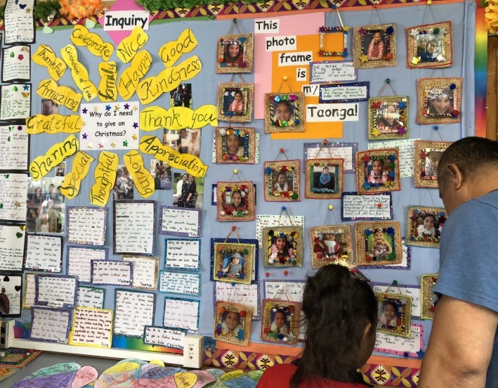
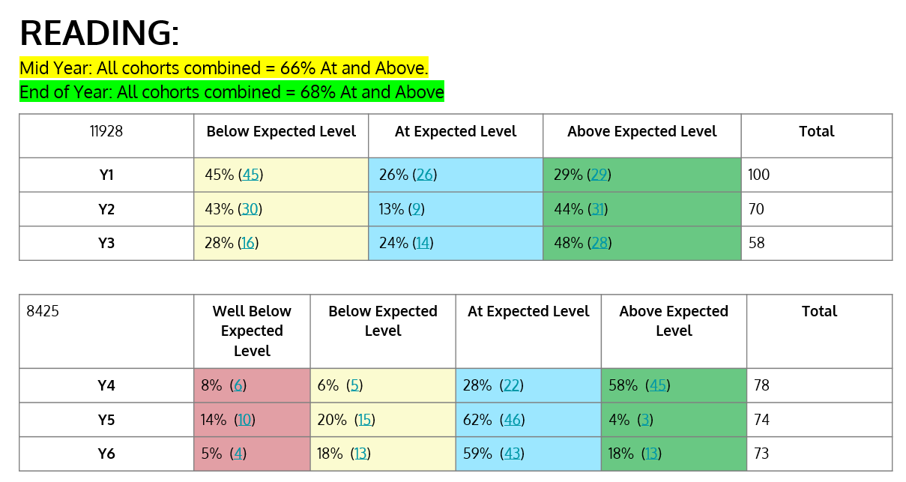
- Year 1 cohort 55% At/Above
- By Year 3 that figure is improved to 72%
- Years 5 and 6 cohort strong at 77% and 84% At/Above
- Year 5 cohort sitting at 66% At/Above
All cohorts
2016: 67%
2017:68%
2018: 67%

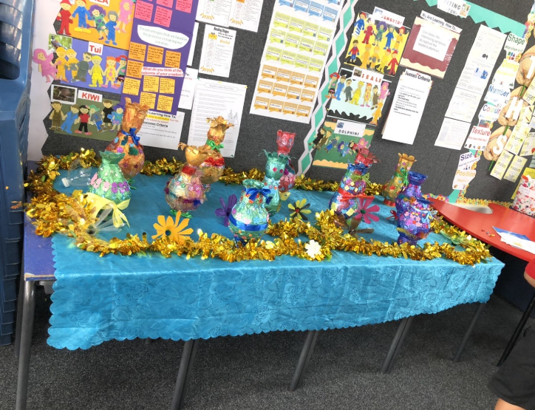
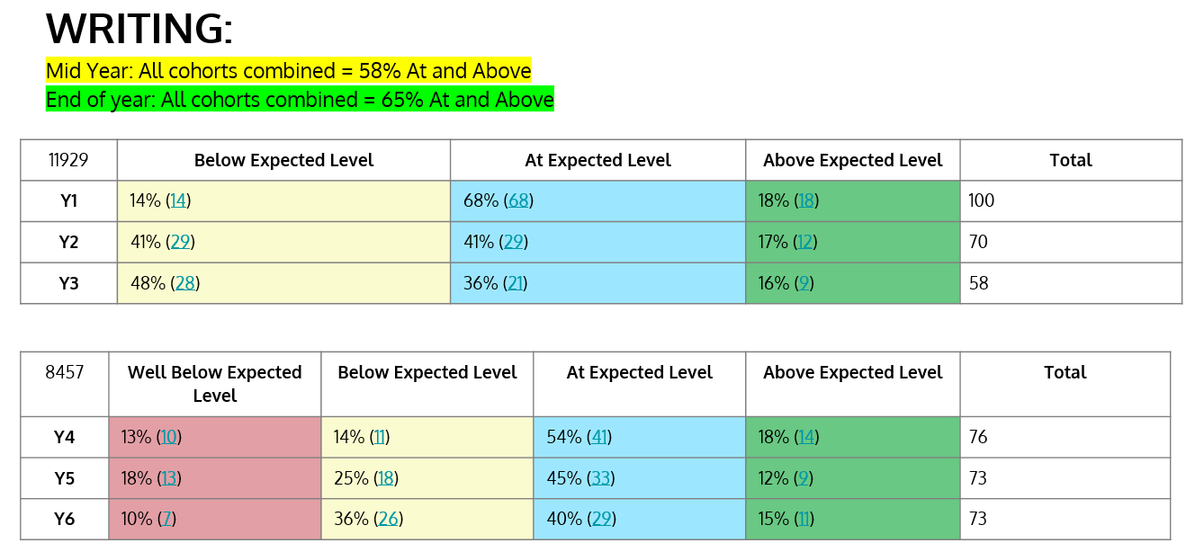
- Year 1 cohort 84% At/Above
- Year 3 chort 73%
- Years 5 and 6 cohort 57% and 55% At/Above
- Year 4 cohort sitting at 72% At/Above
All cohorts
2016: 52%
2017: 46%
2018: 57%

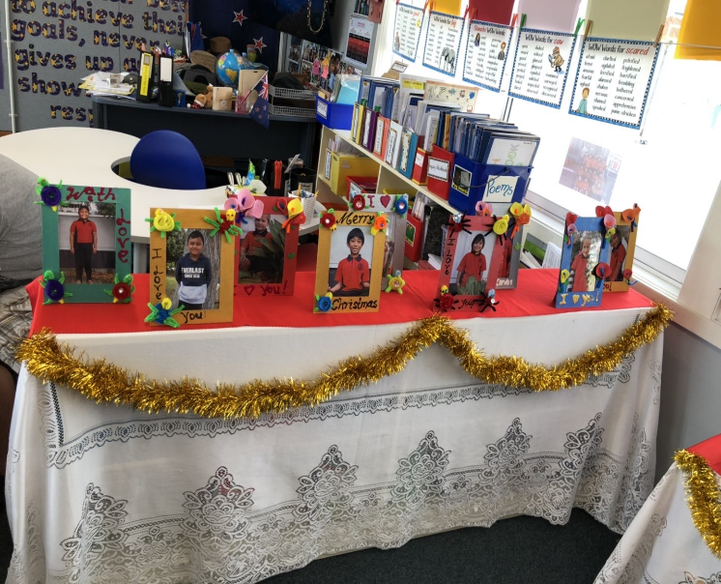
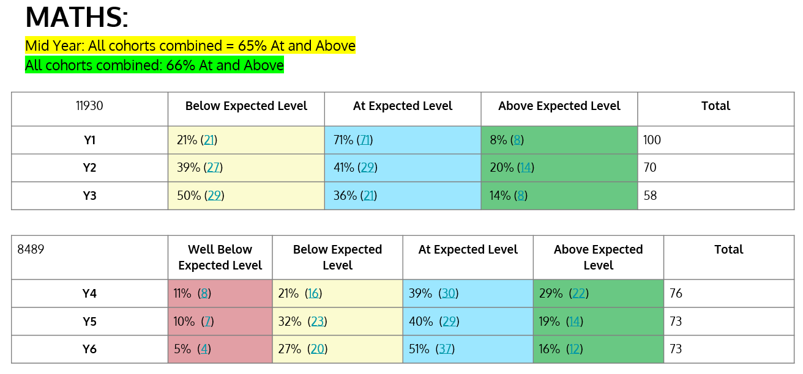
- Year 1 cohort 79% At/Above
- By Year 3 cohort 50% At/Above
- Years 4 and 5 cohort 68% and 59% At/Above
- Year 6 cohort sitting at 69% At/Above
All cohorts
2016: 58%
2017: 54%
2018: 64%

NAG2A (b)(i) Areas of strength
Subjects: Reading, Writing and Mathematics
Discussion
82.0% (64/78) of our Year 3 students At or Above expected achievement level in Reading
76.0% (61/80) of our Year 4 students At or Above the expected achievement level in Reading
76.4% (26/34) of male Pasifika Year 4 students At or Above the expected achievement level in Reading
63.0%% (40/63) of students after 2 years at school At or Above the expected achievement level in Writing
84.0% (72/110) of students after 1 year at school At or Above the expected achievement level in Mathematics.
OTJ’s have been made as a result of an improvement in the moderation and use of assessment data. We have included Running Records as part of a balanced approach to making an OTJ and to include observation, conferencing and regular samples of student work. Year 1-3 teachers use the JAM tool for Mathematics with GLOSS used by Years 4-6 as well as E-AsTTle.
Teachers continue to work on addressing areas of need in comprehension and to utilise PLD from previous years
Reading Recovery available for selected Year 2 students
Library open every lunchtime for students to use
NAG2A (b)(i) Areas for improvement
Subject: Writing and Mathematics
Discussion:
41% (32/78) of all students after 3 years at school Below or Well Below expected achievement level in Writing
40.0% (25/63) of all students after 2 years at school Below or Well Below expected achievement level in Mathematics
46.0% (33/72) of all Years 5 students at Flat Bush School Below or Well Below expected achievement level in Reading
57.0% (41/72) of all Years 5 students at Flat Bush School Below or Well Below expected achievement level in Mathematics
53.9% (187/347) of all students at Flat Bush School Below or Well Below the National Standard in Mathematics
NAG2A (b)(ii) Basis for identifying areas for improvement
Discussion:
- Overall Teacher Judgements in 2019 were based on credible assessment data .
- Teachers have developed greater efficacy in the assessing and teaching of Writing and use of E-AsTTle as a formative and summative tool.
- Discussion with teachers has highlighted that the Deliberate Acts of Teaching that support acceleration are not always taking place in Mathematics due to a lack of teacher pedagogical content knowledge.
- Number Knowledge for students upon enrolment is very low and contributes to the large group of students Below the National Standard after 1 year at school.
- Junior Teachers use of the JAM tool in provided rich formative information.
- Ongoing discussion in staff and syndicate meetings focused on Target groups of students.

NAG2A (b)(iii) Planned actions for lifting achievement
Discussion:
The following relates to Reading, Writing and Mathematics;
- Analyse and review assessment information and identify those students who require extra support, through the use of Teacher Aide intervention, or access to external agencies e.g. RTLB, GSE, Speech Language Therapist
- Build on 2019 focus on Teaching as Inquiry
- Teachers to use T1 assessment data to select target groups of students in Reading, Writing and Mathematics
- In 2020 all teachers to complete a cycle of inquiry based upon a targeted Reading, Writing or Mathematics group
- Continue to refine the moderation process at syndicate level to support staff to improve student outcomes and understanding of the National Standards
- Continue to develop teacher capability in the analysis and interpretation of assessment data to ensure we use this data to inform teaching practice. This will be achieved through our on-going Professional Learning and Development in Assessment for Learning.
- Build on current knowledge of assessment tools (E-AsTTle, GLOSS/JAM/Probe) and ensure new staff have a clear understanding of how to use them.
- Ensure teachers are sharing assessment information with students as a way of developing student created learning goals.

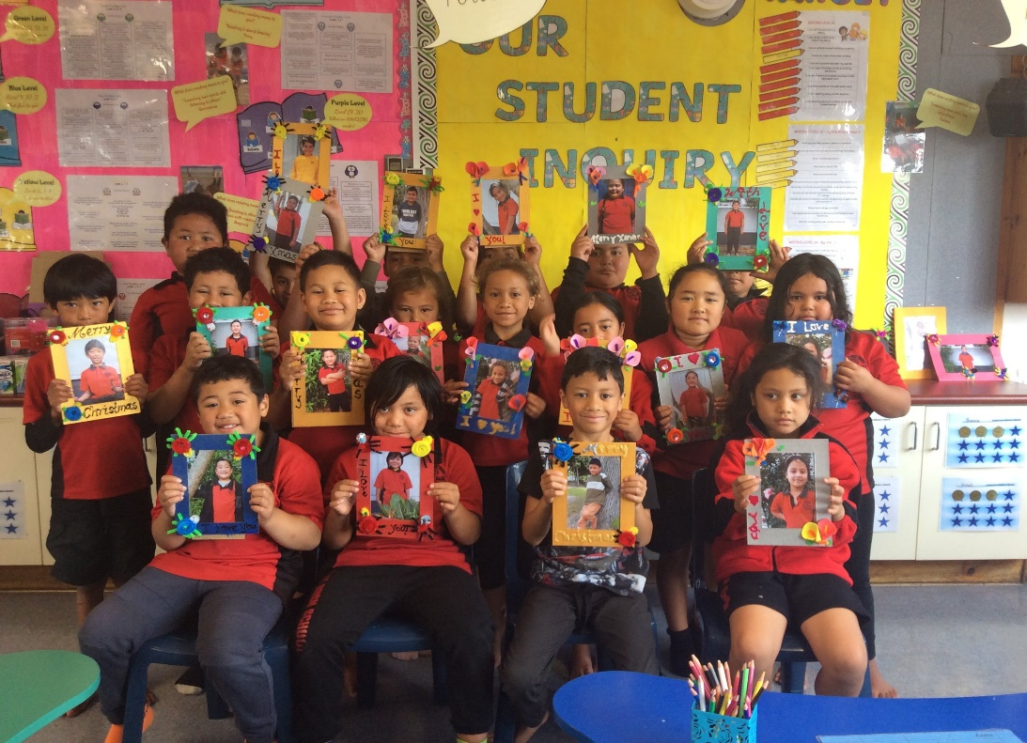

Sources of Information
(how do we know we are achieving where we say we are)

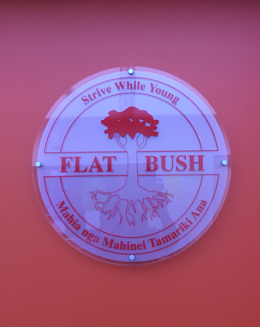
Monthly Principal reporting to the BOT sets out on a preplanned schedule the children’s achievement levels, areas of improvement etc. and includes the sources of information provided each month. Assessment are carried out formally on a preplanned schedule, and informally by teachers as needed
Our main assessments are:

Reading
- Running records (monthly to Level 18, twice a year thereafter)
- PROBE/STAR
- E-AsTTle reading
- Wedge graphs (monthly to year 3)
Maths
- GLOSS (as needed and formally twice a year)
- NUMPA (on entry)
- JAM (Years 1-3)
- E-AsTTle
- Syndicate or level wide pre and post tests in non-numeracy strands
- Basic Facts (twice a year)

In Written Language
- E-AsTTle rubric

In addition to the formal and informal assessment the appraisal system will encourage teachers to select a Target group in either Reading, Writing and Mathematics as the context to frame their 2020 Teaching Inquiry. Appraisal also includes several class observations which add to the information
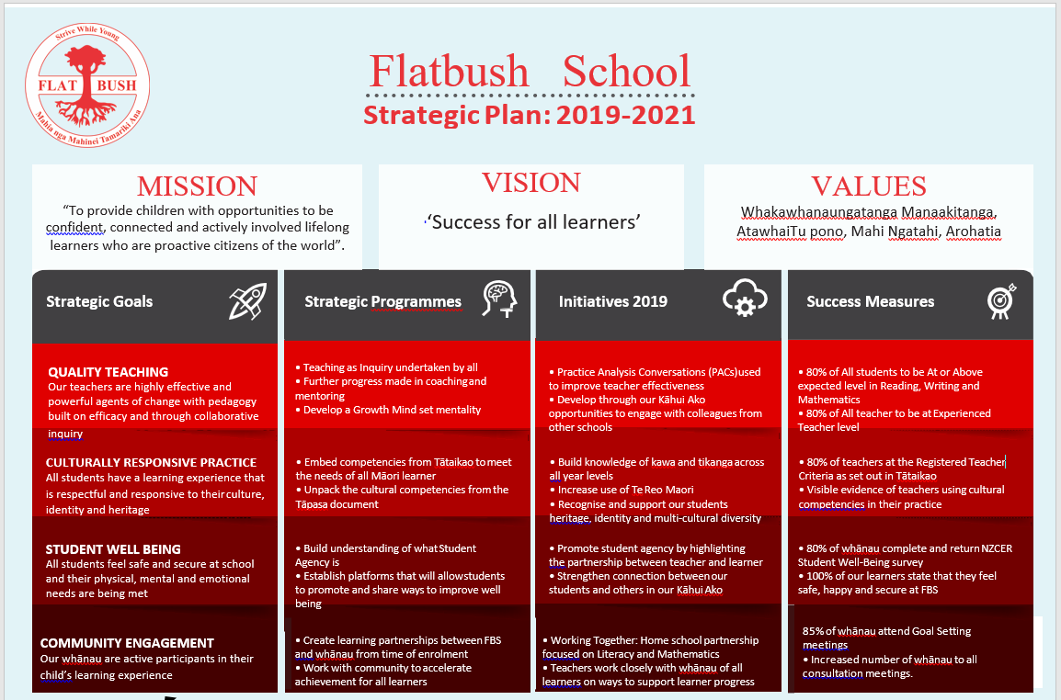
These are used for reports to parents and to the BOT, as well as for decision making relating to resourcing.
Initiative | 2020 |  |  |  | 2021 |  |  |  | 2022
 | T1 | T2 | T3 | T4 | T1 | T2 | T3 | T4 | T1 | T2 | T3 | T4
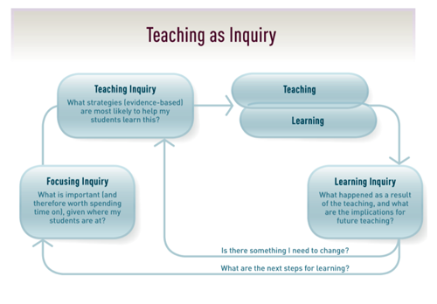  Teaching as Inquiry | Teachers use 2019EOY data as a starting point for selecting target. Complete assessments in core areas, use all data to inform TAI foci for the year (Focusing Inquiry) |  |  |  | Teachers use 2020 EOY data as a starting point for selecting target. Complete assessments in core areas, use all data to inform TAI foci for the year |  |  |  | Teachers use 2021 EOY data as a starting point for selecting target. Complete assessments in core areas, use all data to inform TAI foci for the year
 | Teachers exploring strategies that will be of most benefit to their students (Teaching Inquiry) Teaching and Learning take place. CRT used to support teachers to attend PLD/visit other schools in our Kāhui Ako /observe colleagues in our school |  |  |  | Teachers exploring strategies that will be of most benefit to their students (Teaching Inquiry) Teaching and Learning take place. CRT used to support teachers to attend PLD/visit other schools in and beyond our Kāhui Ako /observe colleagues in our school |  |  |  | Teachers exploring strategies that will be of most benefit to their students (Teaching Inquiry) Teaching and Learning take place. CRT used to support teachers to attend PLD/visit other schools in/beyond our Kāhui Ako and beyond/observe colleagues in our school
 | Teaching and Learning take place. CRT used to support teachers to attend PLD/visit other schools/observe colleagues in our school |  |  |  | Teaching and Learning take place. CRT used to support teachers to attend PLD/visit other schools/observe colleagues in our school |  |  |  | Teaching and Learning take place. CRT used to support teachers to attend PLD/visit other schools/observe colleagues in our school
 | Reflection on Learning Inquiry:what happened as a result of this inquiry/use of information for future teaching. Share TAI with our teaching teams |  |  |  | Reflection on Learning Inquiry:what happened as a result of this inquiry/use of information for future teaching. Share TAI with our Kāhui Ako colleagues |  |  |  | Reflection on Learning Inquiry:what happened as a result of this inquiry/use of information for future teaching. Share TAI with a wider audience of Kāhui Ako
Coaching and Mentoring | Kāhui Ako SMT to continue working with expert partner on strategies to strengthen coaching and mentoring in our schools. Teachers select a practice partner for the year |  |  |  | Teachers in FBS and Rongomai meet to select a practice partner for 2021. |  |  |  | Teachers in Kāhui Ako meet to select a practice partner for 2022.
 | Teachers conduct GROWTH coaching sessions with peers. |  |  |  | Teachers conduct peer observations with PAC supported by DP with curriculum portfolio  FBS Principal observations of FBS teachers in Wk 3 |  |  |  | Teachers conduct peer observations with PAC supported by SMT from Kāhui Ako
 | Teachers conduct peer observations with PAC supported by DP with curriculum portfolio. |  |  |  | FBS and Rongomai teachers meet to have PAC conversations independently |  |  |  | Kāhui Ako teachers meet to have PAC conversations independently
 | Principal PAC with all teachers. |  |  |  | FBS and Rongomai Teachers have PAC conversations based on their 2020 TAI |  |  |  | Kāhui Ako teachers have PAC conversations based on their 2021 TAI
Practice Analysis Conversations | Informal meeting with 2020. practice partner |  |  |  | Meeting with 2020 practice partner from FBS or Rongomai |  |  |  | Meeting with 2021 practice partner from Kāhui Ako agree on foci for the year ahead
 | PAC with practice partner and DP following in class observation |  |  |  | PAC with practice partner and DP following in class observation at FBS or Rongomai |  |  |  | PAC with practice partner and DP following in class observation in our Kāhui Ako
 | PAC with practice partner and DP following in class observation |  |  |  | PAC with practice partner following in class observation |  |  |  | PAC with practice partner following in class observation
 | PAC with practice partner |  |  |  | PAC with practice partner in preparation for sharing of 2020 TAI |  |  |  | PAC with practice partner in preparation for sharing of 2021 TAI
Action Plan 1/Quality Teaching

Action Plan 2/Culturally Responsive Practice

Initiative | 2020 |  |  |  | 2021 |  |  |  | 2022
Te Tataiako | T1 | T2 | T3 | T4 | T1 | T2 | T3 | T4 | T1 | T2 | T3 | T4
Competencies  Ako  Whanaungatanga  Tangata whenuatanga  Manaakitanga  Wānanga | Revisit competencies within Syndicate and Staff meetings |  |  |  | Align competencies with Teaching Standards at Staff Only Day |  |  |  | Align competencies with Teaching Standards at Staff Only Day
 | Unpack Ako, Whanaungatanga competencies during staff PLD (Wks 4, 8) |  |  |  | Students in Year 6 to present examples of what Ako and Whanaungatanga looks like in action at FBS |  |  |  | Students in Year 3 to present examples of what Ako and Whanaungatanga looks like in action at FBS
 | Unpack Tangata whenuatanga,Manaakitanga competencies during staff PLD (Wks 4, 8) |  |  |  | Students in Year 5 to present examples of what Ako and Whanaungatanga looks like in action at FBS |  |  |  | Students in Year 2 to present examples of what Ako and Whanaungatanga looks like in action at FBS
 | Unpack Wānanga competency during staff PLD (Wk 5) |  |  |  | Students in Year 4 to present examples of what Ako and Whanaungatanga looks like in action at FBS |  |  |  | Students in Year 1 to present examples of what Ako and Whanaungatanga looks like in action at FBS
Measurement tool | 80% of all teachers at the Registered Teacher Criteria for all competencies  20% at Leader criteria |  |  |  | 70% of all teachers at the Registered Teacher Criteria for all competencies  30% at Leader criteria |  |  |  | 60% of all teachers at the Registered Teacher Criteria for all competencies  40% at Leader criteria
Tapasā | T1 | T2 | T3 | T4 | T1 | T2 | T3 | T4 | T1 | T2 | T3 | T4
Turu 1:Identities, language and cultures  Turu 2: Collaborative and respectful relationships and professional behaviour  Turu 3: Effective pacific pedagogies | Introduce Tapasā Resource to all staff at our Wk 2 Professional Learning and Development meeting |  |  |  | Revisit competencies at Staff Only Day, (January 27, 2020). Align competencies with current FBS Values |  |  |  | Align competencies with Teaching Standards at Staff Only Day
 | Unpack Turu 1 competency in our staff PLD meetings in Wks 3 and 9 |  |  |  | Turu 1: consult withour FBS community on what they want our school to do to promote identity, language and culture |  |  |  | Students in Years 5-6 to present examples of how our school promotes Identities, Languages and Cultures
 | Unpack Turu 2 competency in our staff PLD meetings Wks 3 and 9 |  |  |  | Turu 2: consult with our FBS community on what they want our school to do to promote collaborative and respectful relationships and professional behaviour |  |  |  | Students in Years 5-6 to present examples of how our school promotes collaborative and respectful relationships
 | Unpack Turu 3 competency in our staff PLD meeting Wk 4 |  |  |  | Turu 3: consult with our FBS community on what they want our school to do to promote effective pacific pedagogies |  |  |  | Teachers to share with FBS community the pedagogies they have found to be impactful within their classroons
Te Puke ō Taramainuku Kāhui Ako | On-going sharing of practice and pedagogy with our Kāhui Ako colleagues
Measurement tool | All teachers at the Experienced Teacher Criteria for all competencies |  |  |  | All teachers at the Experienced Teacher Criteria for all competencies  20% at Leader criteria |  |  |  | All teachers at the Experienced Teacher Criteria for all competencies  30% at Leader criteria

Initiative | 2020 |  | 2021 |  | 2022
Gathering whānau voice | NZCER Community survey with all FBS whānau  80% of all whānau to complete and return survey  Cultural consultation evenings: T1 Target of 70% attendance |  | NZCER Community survey with all FBS and Rongomai whānau  80% of all whānau to complete and return survey  Cultural consultation evenings held as a Kāhui Ako  Target of 80% attendance of all whānau from Years 1-10 |  | NZCER Community survey with all FBS, Rongomai and FIS whānau. 80% of all whānau to complete and return survey  Cultural consultation evenings held as a Kāhui Ako  Target of 90% attendance of all whānau from Years 1-10
Focus on student learning | Goal setting T1/3: Target of 80% attendance all whānau  Conferences: T2/4 : Target of 80% attendance all whānau |  | Goal setting T1/3: Target of 90% attendance all whānau  Conferences: T2/4 : Target of 90% attendance all whānau |  | Goal setting T1/3: Target of 95% attendance all whānau  Conferences: T2/4 : Target of 95% attendance all whānau
Home School partnership | Kāhui Ako Curriculum evenings T1-3: target of 70% attendance  Pacific Parent Responsive Programme (25 families) |  | Kāhui Ako Curriculum evenings T1-3: target of 70% attendance |  | Kāhui Ako Curriculum evenings T1-3: target of 70% attendance
External partnerships | Identify current external supporters of the schools in our Kāhui Ako e.g. Du Val Foundation /AUT/MIT etc. Contact supporters and invite to a meeting of our Kāhui Ako to discuss how we can build/strengthen our working relationship and to explore further possible ways to do this. Create a working group of 3-4 from across Kāhui Ako to attend U-Learn 2020. |  | Kāhui Ako has a group of external supports providing pathways for our students to explore as part of on-going work experience or moving into full time study or employment. Create a working group of Yr 11-12 students (6-8), who have the responsibility of gathering info on what their peers want to study or areas they would like to work in. These students to attend U-Learn 2021. |  | All Year 11-13 students and their whānau in our Kāhui Ako are invited to an information that will be run by the 2021 working group.
Community Events | T1 | School Picnic/Goal setting  LEOTC/Sports/Have a Go Day/weekly assemblies  Cultural consultation meetings | T1 | School Picnic/Goal setting  LEOTC/Sports/Have a Go Day/weekly assemblies  Cultural consultation meetings | T1 | School Picnic/Goal setting  LEOTC/Sports/Have a Go Day/weekly assemblies  Cultural consultation meetings
 | T2 | Student Led conferences  Language weeks  LEOTC/Sports/weekly assemblies | T2 | Student Led conferences  Language weeks  LEOTC/Sports/weekly assemblies | T2 | Student Led conferences  Language weeks  LEOTC/Sports/weekly assemblies
 | T3 | Goal setting  Language Weeks/LEOTC/Sports  Curriculum evening/Book Week/Student Inquiry Expo | T3 | Goal setting  Language Weeks/LEOTC/Sports  Curriculum evening/Book Week/Student Inquiry Expo | T3 | Goal setting  Language Weeks/LEOTC/Sports  Curriculum evening/Book Week/Student Inquiry Expo
 | T4 | LEOTC/Sports/weekly assemblies  Year 6 education experience  NZCER Community Survey  School Concert/Prizegiving/Year 6 Graduation | T4 | LEOTC/Sports/weekly assemblies  Year 6 education experience  NZCER Community Survey  School Concert/Prizegiving/Year 6 Graduation | T4 | LEOTC/Sports/weekly assemblies  Year 6 education experience  NZCER Community Survey  School Concert/Prizegiving/Year 6 Graduation
Action Plan 3/Student Well Being

Action Plan 4/Community Engagement
Initiative | 2020 | 2021 | 2022
Engage with community | Align our FBS Values with those of our Te Puke ō Taramainuku Kāhui Ako with the intention of merging into one  Introduce concept of Whānau Friday (weekly 9am-10.30am), open door pop in/pop out invitations to join in class programmes  Community satisfaction surveys (T2/4) | Review our FBS Values that are aligned with our Te Puke ō Taramainuku Kāhui Ako at a community hui to celebrate the beginning of our new school year.  Continue to promote Whānau Fridays  Community satisfaction surveys (T2/4) | FBS community hui to launch the new school year, at this meeting create examples of what our Values ‘in action’ looks like.  Use these examples as part of upgrading school signage around our school  Whānau Fridays  Community satisfaction surveys (T2/4)
Student Council | Years 5-6  School Council to meet with DP 2 times per term  Selected Year 3-4 students to attend 1 meeting per term | Years 3 and 4 added  School Council to meet with DP 2 times per term  SWIS/RTLB/SMT/CPT invited to attend a combined pastoral care meeting in 2020  Selected Year 1-2 students to attend 1 meeting per term | Years 1-2 added  Full school council representing Years 1-6 meet with DP 2 times per term  SWIS/RTLB/SMT/CPT invited to attend a combined pastoral care meeting in T2/4 2021
Student Agency | Establish focus groups to enable greater student voice to be heard and involved in decision making  Termly student survey (Google forms) of that term’s Inquiry | Focus groups/class discussions/Think Tanks to enable greater student voice to be heard and involved in decision making  Termly student survey (Google forms) of that term’s Inquiry | Focus groups/class discussions/Think Tanks to enable greater student voice to be heard and involved in decision making  Termly student survey (Google forms) of that term’s Inquiry
Responsive Curriculum | Use students survey responses to inform the following term’s Inquiry  Students participating in community based projects e.g. Pay It Forward  Term 4 review of 2020 Inquiry by all students, responses used to guide the Inquiry Topics for 2021 | Student directed Inquiry topics implemented in Terms 2 and 4. Create opportunities for students at all year levels to have input into the planning and preparation of these topics.  Students participating in community based projects e.g. Pay It Forward  Term 4 review of 2021 Inquiry by all students, responses used to guide the Inquiry Topics for 2022 | Student directed Inquiry topics implemented in Terms 1-4. Create opportunities for students at all year levels to have input into the planning and preparation of these topics.  Students participating in community based projects e.g. Pay It Forward  Term 4 review of 2022 Inquiry by all students, responses used to guide the Inquiry Topics for 2023
Measurement Tools | NZCER student well-being survey Years 4-6  Schoolwide attendance  FBS whānau survey responses  Kāhui Ako survey responses | NZCER student well-being survey Years 3-6  Schoolwide attendance  FBS whānau survey responses  Kāhui Ako survey responses | NZCER student well-being survey Years 1-6  Schoolwide attendance  FBS whānau survey responses  Kāhui Ako survey responses

Annual Plan

FLAT BUSH SCHOOL ANNUAL PLAN 2020
Curriculum Area | Specific Objective | Actions | Expected Outcomes | Responsible | Time | Cost | Evaluation
NAG 1  Curriculum Delivery | Ensure effective pedagogy is occurring in all rooms | Classroom observations  Buddy Coaching  Learning Conversations in team and staff settings | Improved learning outcomed for all students | Evaluation Associates PLD facilitator  Management | All Year | Nil | End of 2020
Assessment | Effective use of assessment tools  Ensuring assessment data informs teacher planning and delivery | E-AsTTle, and STAR testing results as pre and post measures for teachers by comparing scale scores in Feb, June and November  Assessments are done on child’s anniversary in junior school not end of year  Looking at the assessment data and looking at teachers planning and implementation | Standard scores vs Stanines gives better teacher knowledge  All assessment information is used formatively to guide classroom learning programmes  Assessments do occur on anniversary  Via performance management ensure teachers are analysing data and using to inform teaching | Management and Syndicate leaders  Evaluation Associates PLD facilitator  James/Janetta  Team Leaders | All Year | $3600 | End of 2020
Mathematics | Improve Maths levels across the school.  Strengthen teacher’s knowledge of how to deliver DMIC | DMIC methodology used in all classes. PLD as part of our Kāhui Ako available for all teachers.  Build Teacher Capability through visiting schools that have had success in developing a DMIC methadology | Teacher’s pedagogical  Skills in Maths increases and children’s learning outcomes improve.  Accelerated progress for Target students | James, Maths Team Leader,Banapa  James, Maths Team Leader | Terms 1 - 4  All year | Nil:  $2000.00 for Teacher release | End of 2020  End of 2020
Te Reo Māori me ona tikanga  Unique position of Māori Culture | To develop Te Reo Māori me ona tikanga | Develop Te Reo to conversational level with 80% of our Year 6 learners  Whaea Dinah and Banapa to support Natasha Young in the delivery of Te reo across the school.  To continue to develop Kapa Haka within Senior and also in 2020 Years 1-3. | Fluency of Te Reo used by students in Years 5-6  Greater use of te reo across the school.  School will have a Kapa Haka group that is confident and proud to support school protocols. | Natasha Young  Classroom teachers  As above | All year  All year  All year | Refer to budget | End of 2019  End of 2019
Cultural diversity Pasifika - Samoan | To provide learning focus on Samoan identity, language and culture. | To extend criteria for selection in Rooms 8, 17, 18, to include students of Samoan heritage with or without the language. | Students with Samoan heritage will have and enhanced sense of identity, language and culture.  More even distribution of students across the school. | Teachers of Rooms 8, 12,17.  Focus rooms Lead Teacher  Principal | All year | As per budget  1 FT Unit | End of 2019
Reading | To accelerate selected student achievement in reading | Introduction of Lexia Reading programme | Acceleration of selected students | Year 6 cohort | Terms 1-4 | $1,000 | End of 2019
Working Together | Improve whanau involvement | Programme continues in 2019 aimed at increased whanau involvement and knowledge, targeting reading and maths. | Reading and Maths outcomes improve  Whanau involvement improves | Liz Heather | All year | - Staffing  1 FT Unit | End of 2019
Reading Together | Improve reading at home | Continue the programme for at least one group per term aiming at the New Entrant parents | Improved learning outcomed for all students | Liz Heather | Terms 1 and 3 |  | End of 2019
E-Learning | Consolidate the existing e-learning classrooms taking place across the school. | Year 1-3 classes to have access to 8 Ipad devices  Year 3-6 classes to have access to 25 Chromebooks | Students are effective users of the technology  Students are effective problem solvers  Learning improves via enthusiasm for learning brought about by the technology | Emily | .1 release | $12,000 (release) plus 4 days for Emily to work with Jacqui Sharp | End of 2019
Music | Use and outside expert to deliver Drumming lessons to all classes | Staff may be more willing to take music groups (Ukelele etc) if there is expert help | School ukelele group performs at Music festivals |  |  | $7,000 | End of 2019
NAG 2 | See the school's self-review cyclical plan | Use Paul M again for management appraisal  Review all internal financial systems | Appraisal provides a PD component for management | Banapa, Janetta James, Tofa |  | $6000 | End of 2019
NAG 3 | Teacher Appraisal through Arinui tool  Job descriptions for all Staff, Teachers, Teacher Aides etc.  Managing workloads: focus on Staff Well Being in 2019 | Teachers understand the new requirement for registration and what they will have to do for their part for appraisal.  Work with Evaluation Associates on professional conversations and how a focus on student achievement will improve learning outcomes  Job descriptions are revised as necessary, and if needed performance agreements are negotiated.  Performance management for office and grounds staff is fully implemented  Continue to look at teacher workloads and find further ways to manage and reduce them. | Arinui is the on-line portal for teacher reflections that align with our school wide focus on Teaching as Inquiry  Appraisal for all staff takes place in 2019 | Banapa, Julie James, Team Leaders  Evaluation Associates PLD facilitator  Banapa / James/Janetta  Anne V/Banapa | Term 1 onwards  Term 2  Term 1 onwards | $8000  Nil  $3,000 | End of 2019  End of 2019  End of 2019
NAG 4 | Create a break out the repurposing of the old Dental Clinic  School Building WOF up to date  Installation of Astroturf basketball courts in Senior and Junior School | Contractors refurbish area,all work is code compliant  School is compliant with all requirements  School is compliant with all requirements | Minimal disruption to mainstream of school, design matches existing buildings | Banapa  Banapa/Ian/Tom  Banapa/Ian | All Year  Term 1 break | 5YA MOE funding  $80.000  (lease agreement with Equico)  Nil | End of 2019
NAG 5 | Develop an effective Health and Safety committee | The committee starts to meet regularly. Make provision for changes from the new act | Health and Safety issues come to committee which deals efficiently and effectively with them. | Banapa | Term 1, then ongoing | Release day/days as needed | End of 2019
NAG 6 | Review reporting to parents.  Civil Defence / Emergency | Ongoing review, especially of reports and NS reporting  Emergency document updated | All documentation is up to date | BOT / Banapa  Administration | On-going  March | Nil | End of 2019

